**API SEA GAME PROJECT**

* List all the events in Sea Game

<http://127.0.0.1:8000/api/listAllSports>

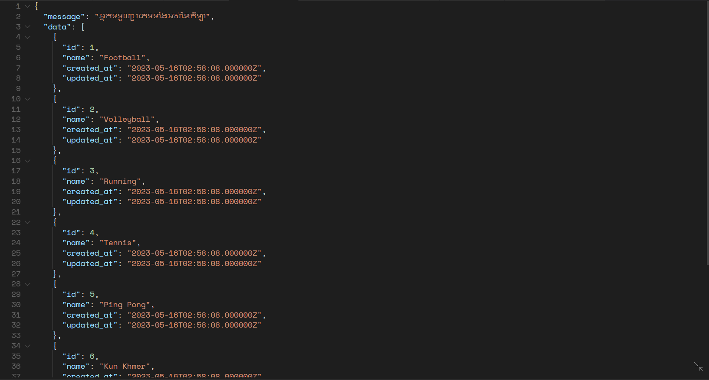

* Search for an event

<http://127.0.0.1:8000/api/search/volleyball>

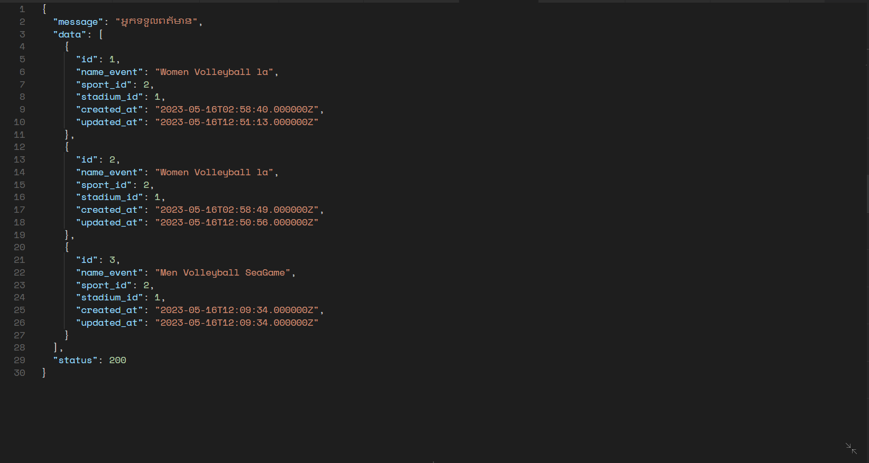

* Get more detail for an event

<http://127.0.0.1:8000/api/getEventDetail/1>

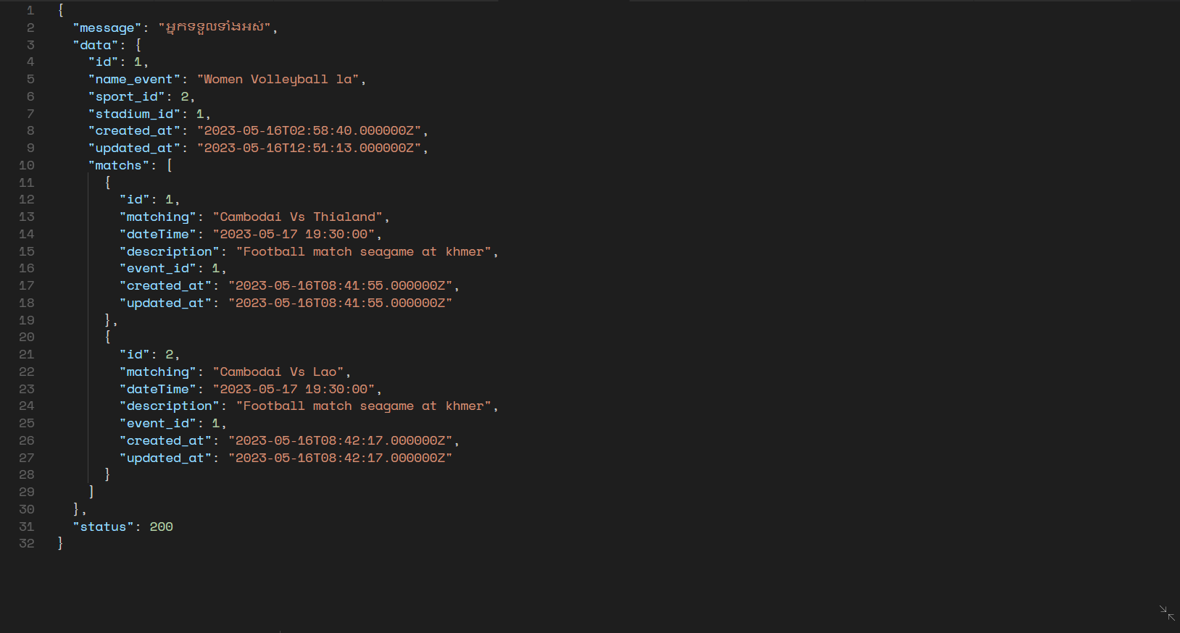

* Booking ticket

<http://127.0.0.1:8000/api/booking>

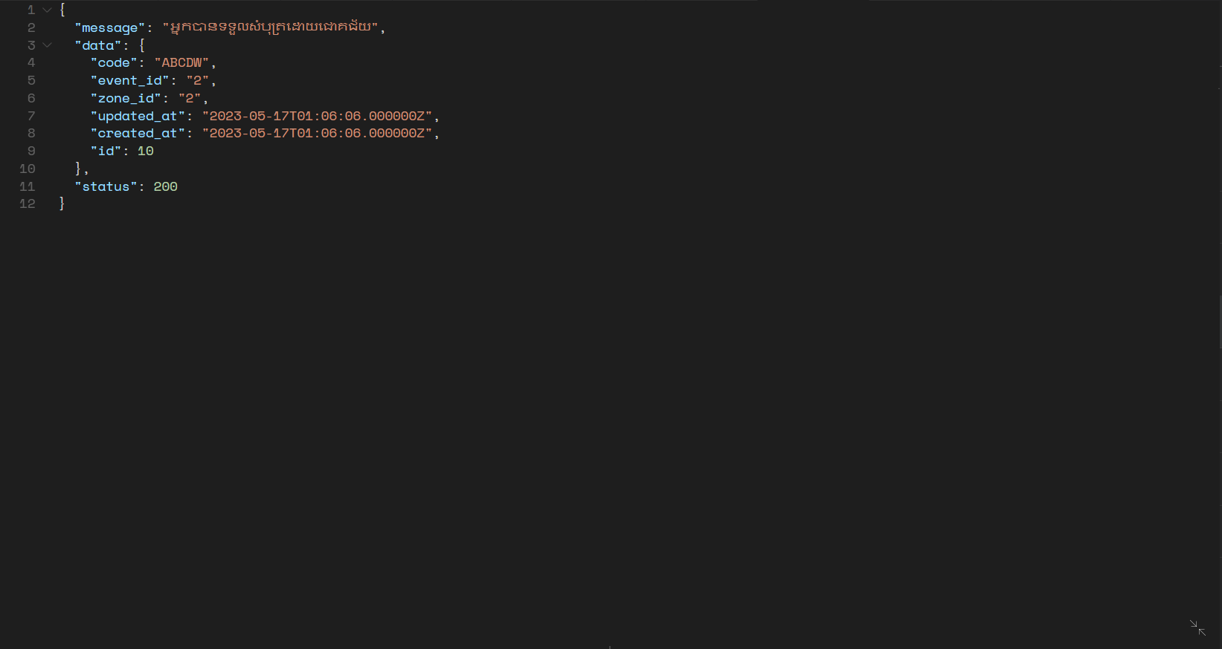

* Create an event

<http://127.0.0.1:8000/api/events>

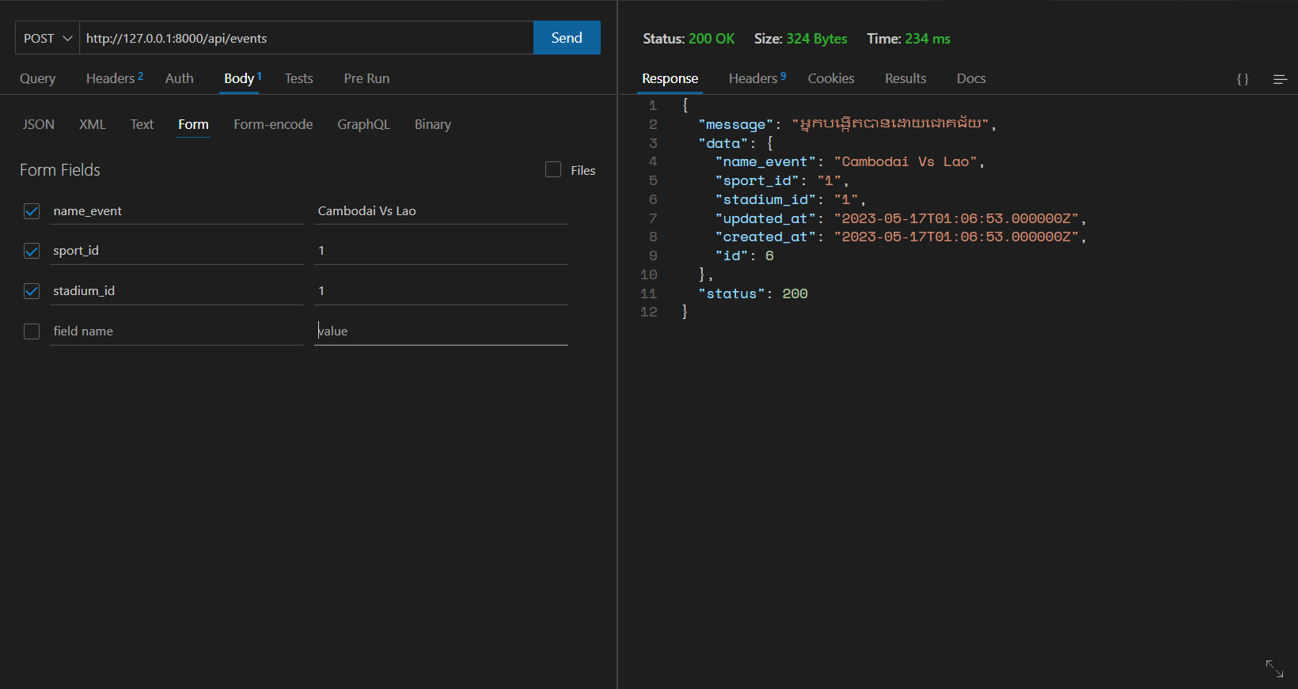

* Delete an event

<http://127.0.0.1:8000/api/delete/1>

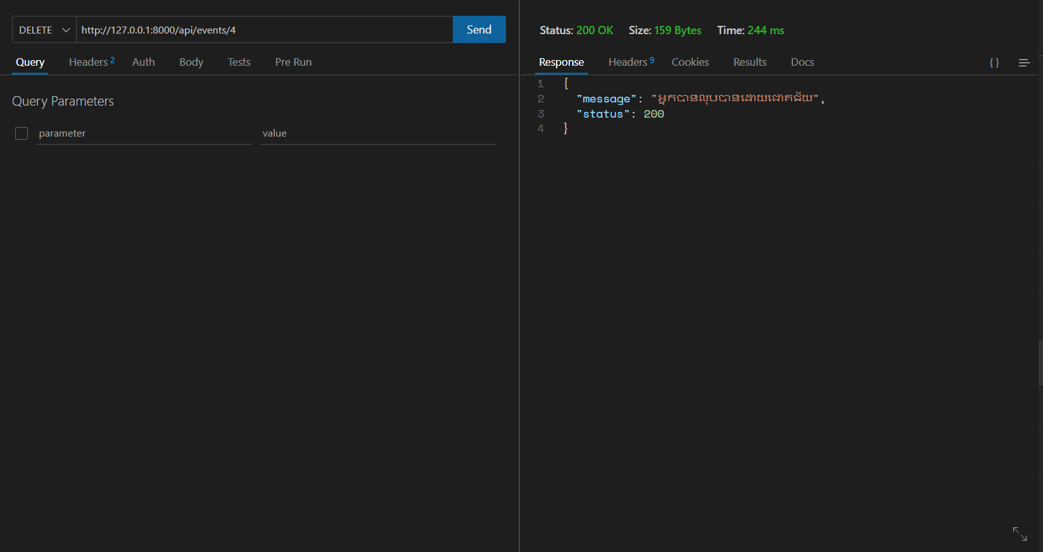

* Edit an event

<http://127.0.0.1:8000/api/events/1>

